Set (Update Price)

Objective
Update a specific book to change its price to 20.20.
Query:-
db.books.updateOne(
{ title: "Rich Dad Poor Dad" },
{
$set: {
price: 20.20
}
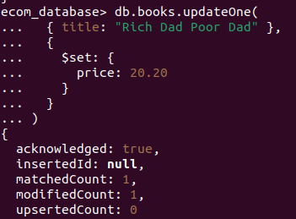
}
)

Explanation
- The $set operator updates the price field of the specified book without affecting other fields.
- This allows modifying only the required data safely.

Push Array (Add New Tag)

Objective
Add a new tag "Best-seller" to the existing Tags array for a specific book.

Query:-
db.books.updateOne(
{ title: "Rich Dad Poor Dad" },
{
$push: {
tags: "Best-seller"
}
}
)
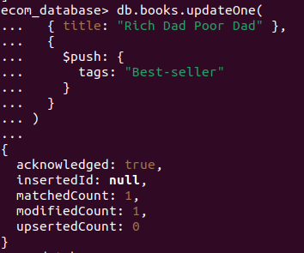

Explanation
- The $push operator adds a new value to an existing array field without overwriting old values.
- This is useful for adding categories, tags, or labels dynamically.

